**Ideation Phase**

**Brainstorm & Idea Prioritization Template**

|  |  |
| --- | --- |
| Date | 26 June2025 |
| Team ID | LTVIP2025TMID35597 |
| Project Name | Pollen's Profiling: Automated Classification of Pollen Grains |
| Maximum Marks | 4 Marks |

**Pollen's Profiling** is a deep learning-based project designed to automate the classification of pollen grains using image processing and machine learning. The system uses Convolutional Neural Networks (CNNs) to classify pollen images based on morphological features such as shape, size, and texture.

**Step-1: Team Gathering, Collaboration and Select the Problem Statement**

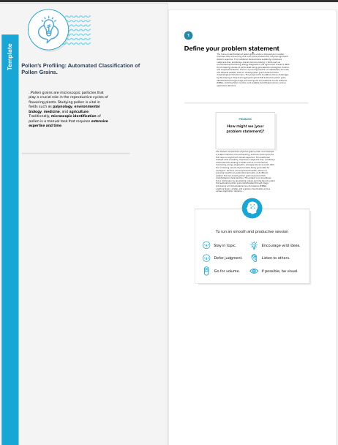

**Step-2: Brainstorm, Idea Listing and Grouping**

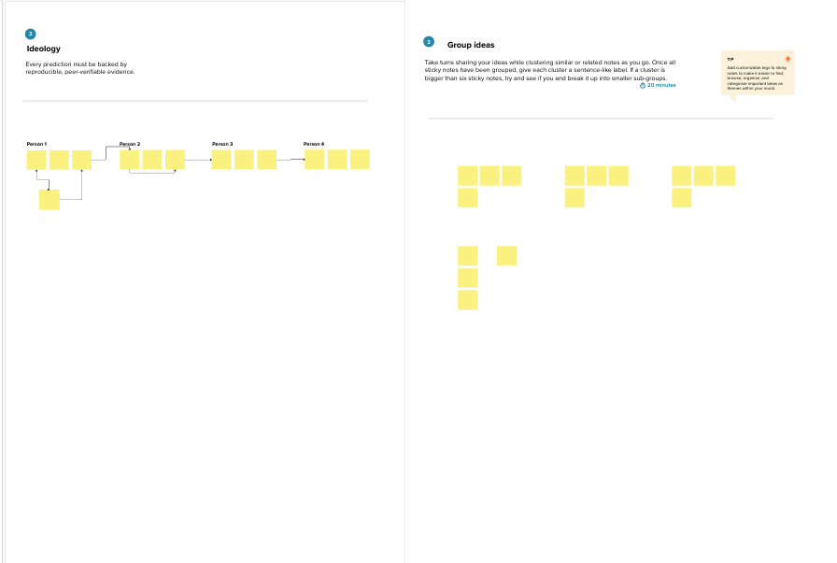

**Step-3: Idea Prioritization**

